**OBJECTIVE ANALYSIS**

**OBJECTIVE**: To check if there is any relation between ‘Life Expectancy’ and ‘Population of Countries around the World in 2015’.

**Tests Performed:**

1. Chi-Square test of Independence. (MS Excel)

**Chi-Square test of Independence**

To perform test with ease, intervals were created to fit the large data into buckets that facilitate efficient conduction of said test.

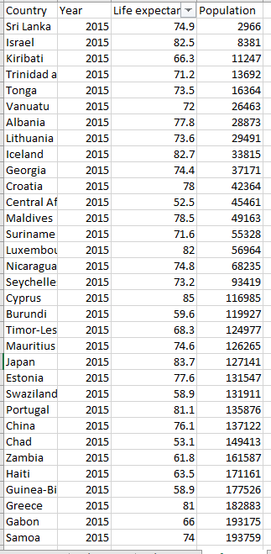

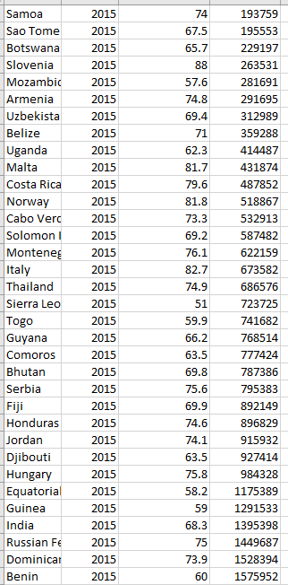

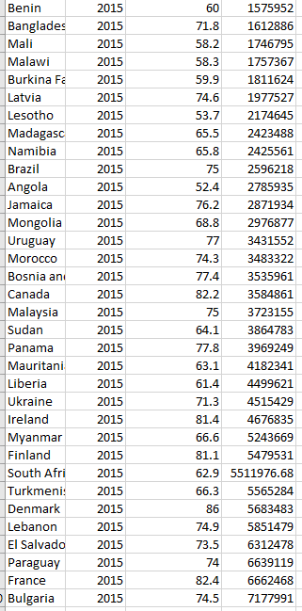

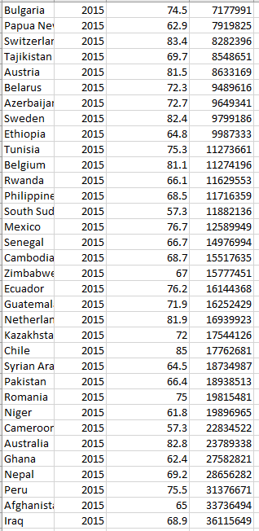

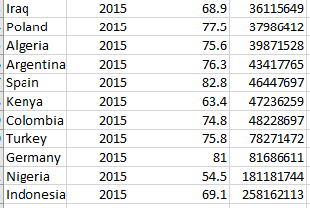

The Intervals that were considered are as follows:

1. For Life Expectancy: Less than 60; 60 to 70; 70 to 80; 80 to 90.
2. For Population of countries: Less than 1000000; 1000000 to 10000000; more than 10000000

**The Observed Frequency Table is as follows:**

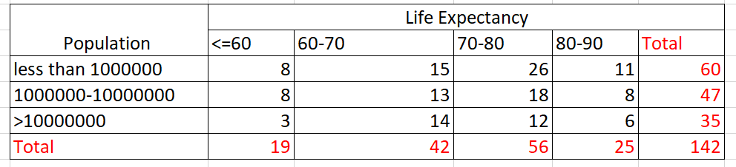

**The Expected Frequency Table is as follows:**

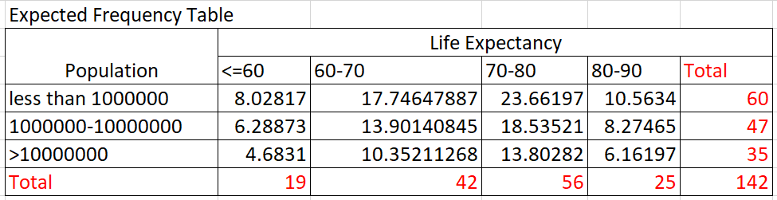

**Calculation of Chi-Square Statistic was done as follows:**

Level of significance is assumed to be 5%.

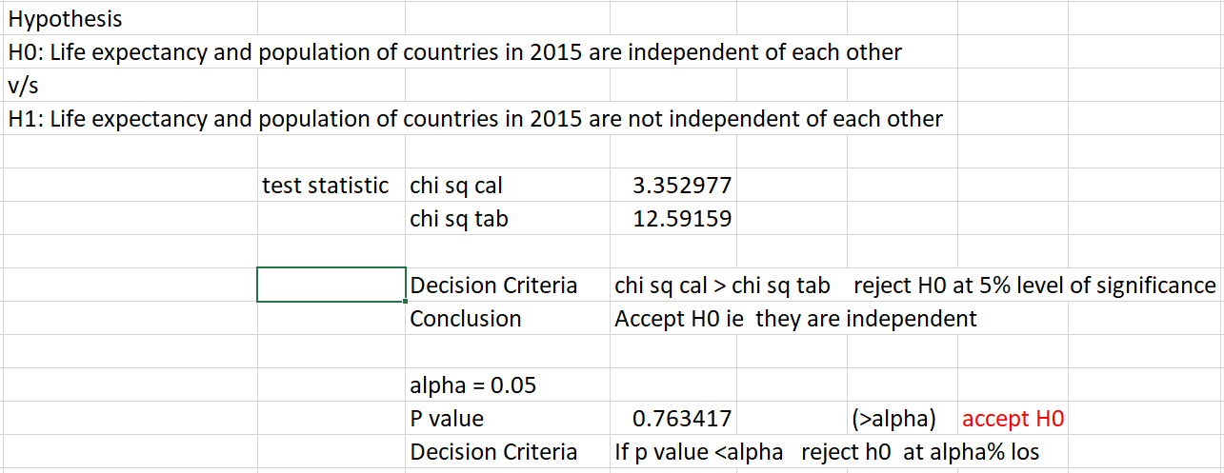

**Conclusion:**

Shown above, the value of calculated Chi-Square statistic is 3.352977 and the Chi-Square Tab value is 12.59159. We can see that Chi-square Cal < Chi-Square Tab and therefore, we accept the null hypothesis I.e. Life expectancy and population are independent of each other.

The P value for the data is 0.763417 and the alpha is taken as 0.05.

Since P value> alpha, we accept the null hypothesis.

**We conclude that ‘Life Expectancy’ and ‘Population of Countries around the World in 2015’ are independent of each other.**